Subject: Physics
Lab 5: Inelastic and Elastic Collisions
Name:
Date of Experiment:
Submission date:
Lecturer’s Name:

OBJECTIVE
The main objectives of this experiment was:
- To test how the conservation of momentum occur during collision processes.
- To test that impulse equals to the change in momentum.
- To analyze how kinetic energy is conserved in elastic collisions
- To analyze how kinetic energy is not conserved in inelastic collisions and finally,
- To analyze the properties of one dimensional collision.
EQUIPMENT
- Air table with pucks and elastic/inelastic collision sets
- 2 cart weights
- Force sensor
- Small Rod
- Table clamp
- Pasco dynamics track with two carts
- Two motion sensors

THEORY AND EQUATIONS
Conservation of energy and momentum plays an important role in fundamental symmetries of physical nature. In this experiment, we analyzed and tested how conservation of momentum occur during collision processes,
Momentum is the product of mass and velocity of a given particle;
p = m v (1)
Momentum is associated with motion of an object and therefore, it is a vector quantity hence, direction is a necessary part of the momentum. Momentum is defined in three-dimensional spaces, x, y and z and the momentum of system of more than one particle is the vector sum of individual momenta.
P₁ +P₂ +P₃ ………. = m₁ v₁ + m₂ v₂ + m₃v₃
According to 2nd Newton’s law of motion, the rate of change in momentum of a system equals to the sum of external forces acting on a system and the energy associated with change in momentum is kinetic energy. The kinetic energy is the form associated with motion of particle and is expressed as:
KE = $\frac{Mv^{2}}{2}$
Collisions plays an important part in testing the application of conservation of momentum, it is hard to assess how collision of bodies interact with each other but with a closed system conservation laws are easy to assess especially in elastic and inelastic collisions.
Conservation of momentum states that the total momentum before collisions should be equal to total energy after collision i.e.
P_{i} = m_{1i} v_{1i} + m_{2i} v_{2i}
P_{f} = m_{1f} v_{1f} + m_{2f} v_{2f}
P_{i =} P_{f} (3)
In an Elastic collision, when two bodies come together, collide and move apart, there is no loss in the total kinetic energy, therefore there is conservation of momentum. But for an Inelastic collision, there is some loss in the total kinetic energy after collision i.e. some energy is converted to other forms of energy but momentum is still conserved.
In this experiment, we dealt with:
- An inelastic collision where all kinetic energy relative to the center of mass of the given system was lost and momentum conserved.
- An elastic collision where both kinetic energy and momentum is conserved.

SUMMARY OF PROCEDURE
Measured M₁, M₂, V_{1ix}, V_{2ix}, V_{1fx} and V_{2fx} for the following situations.
- Equal masses, one cart at rest.
- Unequal masses, one cart at rest.
- Any masses, carts holder towards each other.
Followed the above procedure for each of the 3 scenarios i.e. explosion, elastic and inelastic

DATA AND OBSERVATION
M₁ Blue car mass = 251.3g
M₂ Red car mass = 254.5g
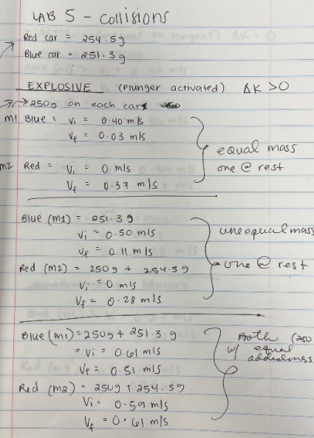

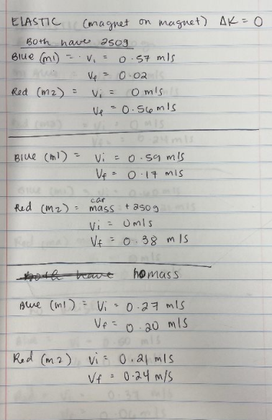
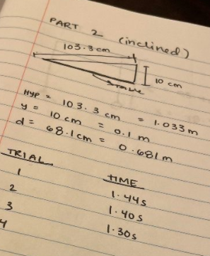

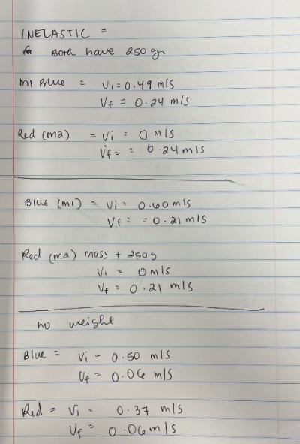
DATA ANALYSIS AND RESULTS
Explosive plunger activated) $∆k>0$
M₁ blue car:  = 250 g | Velocity | Equal Mass, one car at rest
Vi | = 0.4m/s
Vf | = 0.03m/s
M₂ red car:  =250 g | Velocity | Equal Mass, one car at rest
Vi | = 0m/s
Vf | = 0.37m/s

Momentum
P_{i,x total} = m_{1i} v_{1i x} + m_{2i} v_{2ix}
250g* 0.4 + 250g*0 = 100 g.m/s
P_{f,x final} = m_{1f} v_{1fx} + m_{2f} v_{2fx}
250g* 0 .03+ 250*0.37 = 100 g.m/s
Percentage difference = $\frac{Pf-Pi}{\frac{1}{2}(Pf+Pi)}$* 100%
P.D = $\frac{100-100}{\frac{1}{2}(100+100)}$* 100% = 0%
Kinetic energy
K.E_{ix} = $\frac{M1{Vi}^{2}}{2}+ \frac{M2{Vi}^{2}}{2}$
K.E_{ix} = $\frac{250*{0.4}^{2}}{2}+ \frac{250*0}{2}$ = 20 J
K.E_{if} = $\frac{M1{Vf}^{2}}{2}+ \frac{M2{Vf}^{2}}{2}$
K.E_{fx} = $\frac{250*{0.03}^{2}}{2}+ \frac{250*{0.37}^{2}}{2}$ = 17.225 J
$∆K.E= -2.775J$
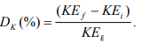= $\frac{17.225-20}{20}$*100% = -13.875%
Pi = Pf hence momentum is conserved but some kinetic energy (86.125%) is conserved,
M₁ blue car:  = 251.3 g | Velocity | Unequal Mass, one car at rest
Vi | = 0.5m/s
Vf | = 0.11m/s
M₂ red car:  = 250 g + 254.5g = 504.5g | Velocity | Unequal Mass, one car at rest
Vi | = 0m/s
Vf | = 0.28m/s

Momentum
P_{i,x total} = m_{1i} v_{1i x} + m_{2i} v_{2ix}
250g* 0.5 + 504.5g*0 = 125 g.m/s
P_{f,x final} = m_{1f} v_{1fx} + m_{2f} v_{2fx}
250g* 0.11 + 504.5 * 0.28 = 168.76g.m/s
Percentage difference = $\frac{Pf-Pi}{\frac{1}{2}(Pf+Pi)}$* 100%
P.D = $\frac{168.76-125}{\frac{1}{2}(168.76+125)}$* 100% = 29.78%
Kinetic energy
K.E_{ix} = $\frac{M1{Vi}^{2}}{2}+ \frac{M2{Vi}^{2}}{2}$
K.E_{ix} = $\frac{250*{0.5}^{2}}{2}+ \frac{504.5*0}{2}$ = 31.25 J
K.E_{if} = $\frac{M1{Vf}^{2}}{2}+ \frac{M2{Vf}^{2}}{2}$
K.E_{fx} = $\frac{250*{0.11}^{2}}{2}+ \frac{504.5*{0.28}^{2}}{2}$ = 21.29 J
$∆K.E= -9.96J$

= $\frac{21.29-31.25}{21.29}$*100% = -46.78%
Both momentum and kinetic energy are not conserved, final momentum increases by 29.78% while final kinetic energy decreases by 46.78%

M₁ blue car:  = 250g+ 251.3 g = 501.3g | Velocity | equal addition of mass(250g), one car at rest
Vi | = 0.61m/s
Vf | = 0.51m/s
M₂ red car:  = 250 g + 254.5g = 504.5g | Velocity | equal addition of mass(250g), one car at rest
Vi | = 0.59m/s
Vf | = 0.61m/s

Momentum
P_{i,x total} = m_{1i} v_{1i x} + m_{2i} v_{2ix}
501.3g* 0.61 + 504.5g*0.59 = 603.45 g.m/s
P_{f,x final} = m_{1f} v_{1fx} + m_{2f} v_{2fx}
501.3* 0.51 + 504.5 * 0.61 = 563.41g.m/s
Percentage difference = $\frac{Pf-Pi}{\frac{1}{2}(Pf+Pi)}$* 100%
P.D = $\frac{563.41-603.45}{\frac{1}{2}(563.41+603.45)}$* 100% = -6.86 %
Kinetic energy
K.E_{ix} = $\frac{M1{Vi}^{2}}{2}+ \frac{M2{Vi}^{2}}{2}$
K.E_{ix} = $\frac{501.3*{0.61}^{2}}{2}+ \frac{504.5*{0.59}^{2}}{2}$ = 181.075 J
K.E_{if} = $\frac{M1{Vf}^{2}}{2}+ \frac{M2{Vf}^{2}}{2}$
K.E_{fx} = $\frac{501.3*{0.51}^{2}}{2}+ \frac{504.5*{0.61}^{2}}{2}$ = 159.05 J
= $\frac{159.05-181.075}{181.075}$*100% = -12.16%
$∆K.E= -22.025J$
Both momentum and kinetic energy are not conserved, final momentum decreases by 6.86% while final kinetic energy decreases by 12.16 %

Elastic (magnet on magnet) $∆k= 0$
M₁ blue car:  = 250 g | Velocity | Equal Mass, one car at rest
Vi | = 0.57m/s
Vf | = 0.02m/s
M₂ red car:  =250 g | Velocity | Equal Mass, one car at rest
Vi | = 0m/s
Vf | = 0.56m/s
Momentum
P_{i,x total} = m_{1i} v_{1i x} + m_{2i} v_{2ix}
250g* 0.57 + 250g*0 = 142.5 g.m/s
P_{f,x final} = m_{1f} v_{1fx} + m_{2f} v_{2fx}
250g* 0.02 + 250 * 0.56 = 145 g.m/s
Percentage difference = $\frac{Pf-Pi}{\frac{1}{2}(Pf+Pi)}$* 100%
P.D = $\frac{145-142.5}{\frac{1}{2}(145+142.5)}$* 100% = 1.74%
Kinetic energy
K.E_{ix} = $\frac{M1{Vi}^{2}}{2}+ \frac{M2{Vi}^{2}}{2}$
K.E_{ix} = $\frac{250*{0.57}^{2}}{2}+ \frac{250*0}{2}$ = 40.6 J
K.E_{if} = $\frac{M1{Vf}^{2}}{2}+ \frac{M2{Vf}^{2}}{2}$
K.E_{fx} = $\frac{250*{0.02}^{2}}{2}+ \frac{250*{0.56}^{2}}{2}$ = 39.25 J
= $\frac{39.25-40.6}{40.6}$*100% = -3.325%
$∆K.E= -1.35J$

Both momentum and kinetic energy are conserved, final momentum increases slightly by 1.74% while final kinetic energy slightly decreases by 3.325 %

M₁ blue car:  = 251.3 g | Velocity | Unequal Mass, one car at rest
Vi | = 0.59m/s
Vf | = 0.17m/s
M₂ red car:  = 250 g + 254.5g = 504.5g | Velocity | Unequal Mass, one car at rest
Vi | = 0m/s
Vf | = 0.38m/s

Momentum
P_{i,x total} = m_{1i} v_{1i x} + m_{2i} v_{2ix}
250g* 0.59 + 504.5g*0 = 147.5 g.m/s
P_{f,x final} = m_{1f} v_{1fx} + m_{2f} v_{2fx}
250g* 0.17 + 504.5 * 0.38 = 234.21g.m/s
Percentage difference = $\frac{Pf-Pi}{\frac{1}{2}(Pf+Pi)}$* 100%
P.D = $\frac{234.21-147.5}{\frac{1}{2}(234.21+147.5)}$* 100% = 45.43%
Kinetic energy
K.E_{ix} = $\frac{M1{Vi}^{2}}{2}+ \frac{M2{Vi}^{2}}{2}$
K.E_{ix} = $\frac{250*{0.59}^{2}}{2}+ \frac{504.5*0}{2}$ = 43.51 J
K.E_{if} = $\frac{M1{Vf}^{2}}{2}+ \frac{M2{Vf}^{2}}{2}$
K.E_{fx} = $\frac{250*{0.17}^{2}}{2}+ \frac{504.5*{0.38}^{2}}{2}$ = 40.0374 J
= $\frac{40.0374-43.51}{43.51}$*100% = -7.98%
$∆K.E= -3.4726J$

Both momentum and kinetic energy are conserved, change is kinetic energy = -7.98%
M₁ blue car:  = 250g+ 251.3 g = 501.3g | Velocity | equal addition of mass(250g), one car at rest
Vi | = 0.27m/s
Vf | = 0.20m/s
M₂ red car:  = 250 g + 254.5g = 504.5g | Velocity | equal addition of mass(250g), one car at rest
Vi | = 0.21m/s
Vf | = 0.24m/s

Momentum
P_{i,x total} = m_{1i} v_{1i x} + m_{2i} v_{2ix}
501.3g* 0.27 + 504.5g*0.21 = 241.296 g.m/s
P_{f,x final} = m_{1f} v_{1fx} + m_{2f} v_{2fx}
501.3* 0.20 + 504.5 * 0.24= 221.34g.m/s
Percentage difference = $\frac{Pf-Pi}{\frac{1}{2}(Pf+Pi)}$* 100%
P.D = $\frac{221.34-241.296}{\frac{1}{2}(241.296+221.34)}$* 100% = -8.627 %
Kinetic energy
K.E_{ix} = $\frac{M1{Vi}^{2}}{2}+ \frac{M2{Vi}^{2}}{2}$
K.E_{ix} = $\frac{501.3*{0.27}^{2}}{2}+ \frac{504.5*{0.21}^{2}}{2}$ = 29.4 J
K.E_{if} = $\frac{M1{Vf}^{2}}{2}+ \frac{M2{Vf}^{2}}{2}$
K.E_{fx} = $\frac{501.3*{0.20}^{2}}{2}+ \frac{504.5*{0.24}^{2}}{2}$ = 24.56 J
= $\frac{24.56-29.4}{29.4}$*100% = -16.46%
$∆K.E= -5.04J$

Both momentum and kinetic energy are conserved, change is kinetic energy = --16.46%

Inelastic (Velcro on Velcro) $∆k< 0$
M₁ blue car:  = 250 g | Velocity | Equal Mass, one car at rest
Vi | = 0.49m/s
Vf | = 0.24m/s
M₂ red car:  =250 g | Velocity | Equal Mass, one car at rest
Vi | = 0m/s
Vf | = 0.24m/s
Momentum
P_{i,x total} = m_{1i} v_{1i x} + m_{2i} v_{2ix}
250g* 0.49 + 250g*0 = 122.5 g.m/s
P_{f,x final} = m_{1f} v_{1fx} + m_{2f} v_{2fx}
250g* 0.24 + 250 * 0.24 = 120 g.m/s
Percentage difference = $\frac{Pf-Pi}{\frac{1}{2}(Pf+Pi)}$* 100%
P.D = $\frac{120-122.5}{\frac{1}{2}(120+122.5)}$* 100% = -2.06%
Kinetic energy
K.E_{ix} = $\frac{M1{Vi}^{2}}{2}+ \frac{M2{Vi}^{2}}{2}$
K.E_{ix} = $\frac{250*{0.49}^{2}}{2}+ \frac{250*0}{2}$ = 30 J
K.E_{if} = $\frac{M1{Vf}^{2}}{2}+ \frac{M2{Vf}^{2}}{2}$
K.E_{fx} = $\frac{250*{0.24}^{2}}{2}+ \frac{250*{0.24}^{2}}{2}$ = 14.4 J
= $\frac{14.4-30}{30}$*100% = -52%

$∆K.E= -15.6J$
M₁ blue car:  = 251.3 g | Velocity | Unequal Mass, one car at rest
Vi | = 0.60m/s
Vf | = 0.21m/s
M₂ red car:  = 250 g + 254.5g = 504.5g | Velocity | Unequal Mass, one car at rest
Vi | = 0m/s
Vf | = 0.21m/s
Momentum
P_{i,x total} = m_{1i} v_{1i x} + m_{2i} v_{2ix}
250g* 0.60 + 504.5 g*0 = 150 g.m/s
P_{f,x final} = m_{1f} v_{1fx} + m_{2f} v_{2fx}
250g* 0.21 + 504.5 * 0.21= 158.445 g.m/s
Percentage difference = $\frac{Pf-Pi}{\frac{1}{2}(Pf+Pi)}$* 100%
P.D = $\frac{158.445-150}{\frac{1}{2}(158.445+150)}$* 100% = 5.475%
Kinetic energy
K.E_{ix} = $\frac{M1{Vi}^{2}}{2}+ \frac{M2{Vi}^{2}}{2}$
K.E_{ix} = $\frac{250*{0.6}^{2}}{2}+ \frac{504.5*0}{2}$ = 45 J
K.E_{if} = $\frac{M1{Vf}^{2}}{2}+ \frac{M2{Vf}^{2}}{2}$
K.E_{fx} = $\frac{250*{0.21}^{2}}{2}+ \frac{504.5*{0.21}^{2}}{2}$ = 16.63 J
= $\frac{16.63-45}{45}$*100% = -63%
$∆K.E= -28.37J$

M₁ blue car:  = 250g+ 251.3 g = 501.3g | Velocity | equal addition of mass(250g), one car at rest
Vi | = 0.5m/s
Vf | = 0.06m/s
M₂ red car:  = 250 g + 254.5g = 504.5g | Velocity | equal addition of mass(250g), one car at rest
Vi | = 0.37m/s
Vf | = 0.06m/s
Momentum
P_{i,x total} = m_{1i} v_{1i x} + m_{2i} v_{2ix}
501.3g* 0.5 + 504.5g*0.37 = 437.31 g.m/s
P_{f,x final} = m_{1f} v_{1fx} + m_{2f} v_{2fx}
501.3* 0.06 + 504.5 * 0.06 = 60.35g.m/s
Percentage difference = $\frac{Pf-Pi}{\frac{1}{2}(Pf+Pi)}$* 100%
P.D = $\frac{60.35-437.31}{\frac{1}{2}(60.35+437.31)}$* 100% = -151.5 %

Kinetic energy
K.E_{ix} = $\frac{M1{Vi}^{2}}{2}+ \frac{M2{Vi}^{2}}{2}$
K.E_{ix} = $\frac{501.3*{0.5}^{2}}{2}+ \frac{504.5*{0.37}^{2}}{2}$ = 97.2 J
K.E_{if} = $\frac{M1{Vf}^{2}}{2}+ \frac{M2{Vf}^{2}}{2}$
K.E_{fx} = $\frac{501.3*{0.06}^{2}}{2}+ \frac{504.5*{0.06}^{2}}{2}$ = 1.81 J
= $\frac{1.81-97.2}{97.2}$*100% = -98.13%
$∆K.E= -95.39J$
DISCUSION/ CONCLUSION
The experiment was conducted with success and objectives of the experiment achieved, what was expected is that, in explosive collision, the change in initial and final momentum should be the same since it was an isolated system and the change in kinetic energy was expected to be greater than zero. What was obtain is slight change in final momentum hence one can conclude that there was conservation of momentum. However, the change in kinetic energy was less than zero which shows that there were some experimental errors but all in all is that, in an explosive collision, conservation of momentum occurs while final kinetic energy increases.
For the elastic collision, what was expected if a change of kinetic energy that is equals to zero meaning, there should be no change and momentum should also be conserved. What was obtained it that, there was slight change in kinetic energy hence one can conclude that kinetic energy was conserved. There was also a slight change in momentum which one can still conclude that momentum was also conserved.
The third part, inelastic collision gave totally different expectation of conservation of momentum. What was expected in an inelastic collision was total conservation of momentum and a great change in kinetic energy, i.e. kinetic energy change should be less than zero since most of it is converted to other forms of energy. What was achieved is that, change in kinetic energy agreed with our expectation but however, the great change in momentum stated otherwise i.e. that momentum was not conserved.

